Nittetsu Mining Provides Final $1.5 Million Earn-in Payment for Camino’s Los Chapitos Copper Project in Peru

Vancouver, December 3, 2025 – Camino Minerals Corporation (TSXV: COR) (OTC: CAMZF) (“Camino” or the “Company”) is pleased to announce the receipt of the sixth, and final, CAD$1.5 million payment from its exploration partner Nittetsu Mining CO., Ltd. (“Nittetsu”), marking the successful completion of Nittetsu’s earn-in expenditure requirements under the earn-in agreement dated June 13, 2023 (“Earn-In Agreement”) (see news release dated June 14, 2023). Following the conclusion of the current drilling program at the Los Chapitos Copper Project (“Los Chapitos” or the “Project”) in Peru, the Project will be formally converted into a joint venture, with Camino retaining a 65% participating interest, operatorship of the Project, and 50% of the life-of-mine production off-take. Los Chapitos is the second joint venture project with Nittetsu, as Camino is currently advancing the Puquios copper mine development with Nittetsu in Chile.
At Los Chapitos, exploration drilling has commenced on the high-grade copper targets along the Diva and La Estancia trends that were identified earlier in the year, where the recent trench sampling demonstrated high-grade copper structures and copper mantos potential (see news releases dated June 17, 2025 and July 16, 2025).
Camino is currently advancing the fourth drillhole of a planned phased campaign totaling approximately 2,650 metres, and consisting of an estimated 18 drillholes. The ongoing drilling program is expected to continue into the first half of 2026.
“With the joint venture structure soon in place at Los Chapitos, we will continue to drive exploration on the high-grade copper targets we’ve defined across the Diva, Atajo, and La Estancia copper trends” said Jay Chmelauskas, CEO of Camino. “Through our two joint ventures with Nittetsu, we are collaborating on two fronts, building a new copper mine in Chile at Puquios, and continuing discovery drilling at Los Chapitos in Peru.”
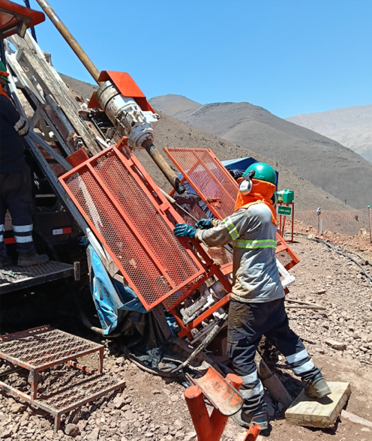
Figure 1. Los Chapitos copper drilling campaign in Peru, December 2025.
Issuance of Shares
The Company intends to issue an aggregate of 139,535 Common Shares (the “Finder Shares”) to Resource Play, an arm’s length third party, at a deemed price of $0.43 per share as a finder’s fee in connection with the Earn-In Agreement entered into by, inter alios, Camino and Nittetsu Mining for the Los Chapitos copper project. The Finder Shares are proposed to be issued in relation to $1.5 million of funds contributed by Nittetsu under the Earn-In Agreement as the sixth option to earn-in payment made by Nittetsu thereunder. The intention to pay the finder’s fee was noted in Camino’s news release dated February 1, 2023, and the Finder Shares are being issued in accordance with the terms of a finder’s fee agreement entered into by Camino and Resource Play dated August 5, 2020, as subsequently extended. The issuance of the Finder Shares remains subject to the acceptance of the TSX Venture Exchange. The Finder Shares to be issued will be subject to a statutory hold period of four months and one day from the date of issuance in accordance with applicable Canadian securities legislation.
About Camino
Camino is a discovery and development stage copper exploration company. Camino is focused on developing copper producing assets such as Puquios, a construction-ready copper mine in Chile, and advancing its IOCG Los Chapitos copper project located in Peru through to resource delineation and development, and to add new discoveries. Camino has also permitted the Maria Cecilia copper porphyry project for exploration discovery drilling to add to its NI 43-101 resources. In addition, Camino has increased its land position at its copper and silver Plata Dorada project. Camino seeks to acquire a portfolio of advanced copper assets that have the potential to deliver copper into an electrifying copper intensive global economy. For more information, please refer to Camino’s website at www.caminocorp.com.
Jose A. Bassan, MSc. Geologist, an independent geologist FAusIMM (CP) 227922, a qualified person as defined by National Instrument 43-101 – Standards of Disclosure for Mineral Projects, has reviewed and approved the technical contents of this document. Mr. Bassan has reviewed and verified relevant data supporting the technical disclosure, including sampling and analytical test data.

ON BEHALF OF THE BOARD | For further information, please contact:
/S/ “Jay Chmelauskas” | Camino Investor Relations
President and CEO | info@caminocorp.com
 | Tel: (604) 493-2058

Neither TSX Venture Exchange nor its Regulation Services Provider (as that term is defined in the policies of the TSX Venture Exchange) accepts responsibility for the adequacy or accuracy of this release.
Cautionary Note Regarding Forward Looking Statements: Certain disclosures in this release constitute forward-looking information within the meaning of applicable securities laws. Forward-looking statements are included to provide information about management’s current expectations and plans that allows investors and others to have a better understanding of the Company’s business plans and financial performance and condition. All statements, other than statements of historical fact included in this release are forward-looking statements that involve risks and uncertainties. Forward-looking information is typically (though not always) identified by words such as “plan”, “expect”, “estimate”, “intend”, “anticipate”, “believe”, or variations of such words and phrases or statements that certain actions, events or results “may”, “could”, “would”, “might” or “will” be taken, occur or be achieved. In making the forward-looking disclosures in this release, the Company has applied certain factors and assumptions that are based on the Company’s current beliefs as well as assumptions made by and information currently available to the Company. Forward-looking information in the release includes, without limitation, statements with respect to exploration work at Los Chapitos, future planned drilling programs, prospectivity for copper exploration in new targets, and the payment of the finder’s fee and the issuance of the Finder Shares. Although the Company considers the assumptions underlying such forward-looking information to be reasonable based on information currently available to it, they may prove to be incorrect, and the forward-looking information in this release is subject to numerous risks, uncertainties and other factors that may cause future results to differ materially from those expressed or implied in such forward-looking information. Such risk factors include, among others, that actual results of the Company’s exploration activities may be different than those expected by management, that the Company may not realize the benefits of joint ventures and/or strategic partnerships with respect to the Company’s properties, that the Company may be unable to obtain or may experience delays in obtaining any required authorizations and approvals and the state of equity and commodity markets. Readers are cautioned not to place undue reliance on forward-looking statements. The Company does not intend, and expressly disclaims any intention or obligation to, update or revise any forward-looking statements whether as a result of new information, future events or otherwise, except as required by law.

